# Automatic start/shutdown of VMs

Now that all VMs have been deployed, we will configure them to automatically start when the server starts and automatically shut down when the server halts. This is a feature only available for standalone servers (which are thus not part of a high availability cluster).

The following steps can both be executed with the vSphere Client or with the vSphere Web Client (https://<vCenterIP>:9443/vsphere-client/).

Log in, go to the host overview & select the host in the left panel.

Go to “Configuration” (or “Settings” > “Manage”).

Select “Virtual Machine Startup/Shutdown”.

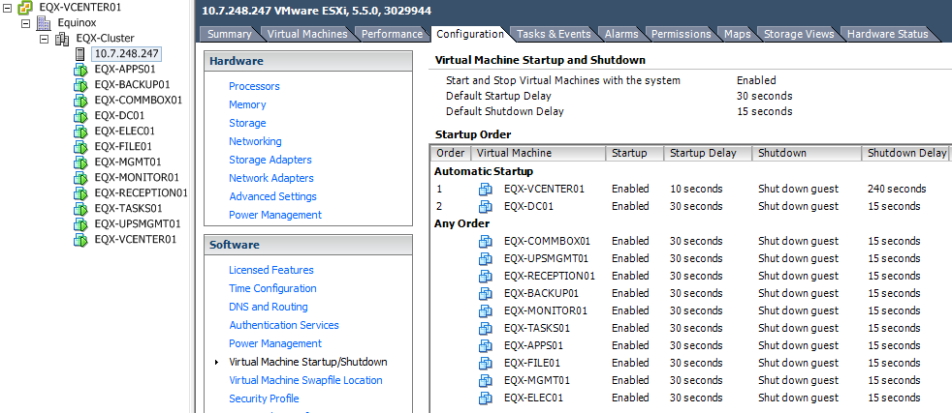

Press “Properties” (or “Edit”)

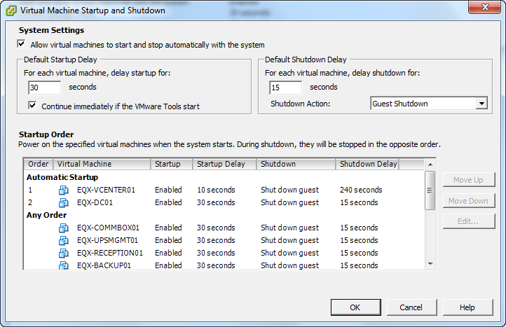

Set “Allow virtual machines to start and stop automatically with the system”.

Configure “Default Startup Delay” as 30 seconds and select “Continue immediately if the VMtools start”.

Configure “Default Shutdown Delay” as 15 seconds, with default shutdown action as “Guest Shutdown”.

Now order the VMs:

Automatic Startup:

1. vCenter,
2. DC.

Any Order:

* All other VMs.

Now select the vCenter and “Edit”. Manually configure the Startup Delay to be 10 seconds and the Shutdown Delay to be 240 seconds. All other VMs should use the defaults as set above.